**Reply to editors**

We thank the editorial board for the opportunity to revise our manuscript. We gratefully acknowledge that the comments of both reviewers were very constructive and have improved the paper. We essentially accommodate all of them; there were no points of disagreement. Our responses to the reviewers’ comments are outlined below in regular font with editor/reviewer’s comments in bold font.

**Your manuscript "Potential gains in life expectancy by reducing inequality of lifespans in Denmark: An international comparison and cause of death analysis" (PUBH-D-18-01180) has been assessed by our reviewers. Based on these reports, and my own assessment as Editor, I am pleased to inform you that it is potentially acceptable for publication in BMC Public Health, once you have carried out some essential revisions suggested by our reviewers.**

Thank you again for considering our manuscript. We have addressed every comment from the reviewers and the editorial team

José Manuel Aburto

Maarten Wensink

Alyson van Raalte

Rune Lindahl-Jacobsen

**Reply to reviewers**

We appreciate the reviewers' comments; their detailed reading of the manuscript and suggestions that have greatly improved the article. Our responses to the reviewers’ comments are outlined below in regular font with reviewer’s comments in bold font.

**Reviewer: 1**

**Henrik Bronnum-Hansen (Reviewer 1): This study gives more insight into the cause of the long lasting and disturbing mortality trends in Denmark. The authors simultaneously investigate trends in life expectancy, lifespan inequality and decomposition by cause of death.**

**The manuscript is well written and my comments, questions and suggestion are few:**

**1. Although life expectancy is well known, lifespan may be less. So as a service for readers not in well-informed circles I recommend to introduce the definition(s) or the overall concept(s) of (life expectancy and) lifespan in the introduction of the paper before describing the characteristics of the two health indicators.**

We thank the reviewer for this suggestion. We have clarified the terms in the first two sentences of the introduction. It now reads:

“Life expectancy at birth is one of the most commonly used measures of the health status of a population and the performance of the healthcare system.(1) It represents the average age at death if everyone experienced the prevailing death rates throughout their lifetime. Another important dimension is the uncertainty around that expectation (i.e. the variation in ages at death) which is also known as lifespan inequality.(2)”

**2. The first sentence on page 3 should start "Life expectancy is one of the most commonly used measure…", because health expectancy and other summary measures of population health become increasingly more widespread.**

Thank you for this observation, we have adjusted the sentence accordingly:

“Life expectancy at birth is one of the most commonly used measures of the health status of a population and the performance of the healthcare system…”

**3. I suggest that you add a little more explanation to the sentence (page5-6): "We also checked for discontinuities in death counts…"? In Figure 2-4 "ICD7" is missing in the description of categories. I am not sure that I understand how to interpret the graphs.**

We gave added further explanation to the sentence, it now reads:

“Our groupings over the various ICD revisions were cross-checked to be consistent with other coding practices across ICD versions in the literature.(29) We also checked for discontinuities in death counts for each of the seven cause-of-death groups over ICD transition years (Supplementary Figure 2). There were no major breaks at years when ICD versions changed, indicating that cause-specific mortality changes were real and not attributable to inconsistencies in coding practice.”

In addition, we have made changes to the graphs in the Supplementary file. We changed the caption to clarify its interpretation and corrected the labels:

“Figures 2. Deaths counts by cause-of-death group for Denmark (panel A) and Sweden (panel B). Colored-vertical lines indicate changes in ICD revisions. For example, in the case of Denmark, the green vertical line indicates the change from ICD 7 to ICD 8, which was on 1969.”

For Denmark, the figure now shows:

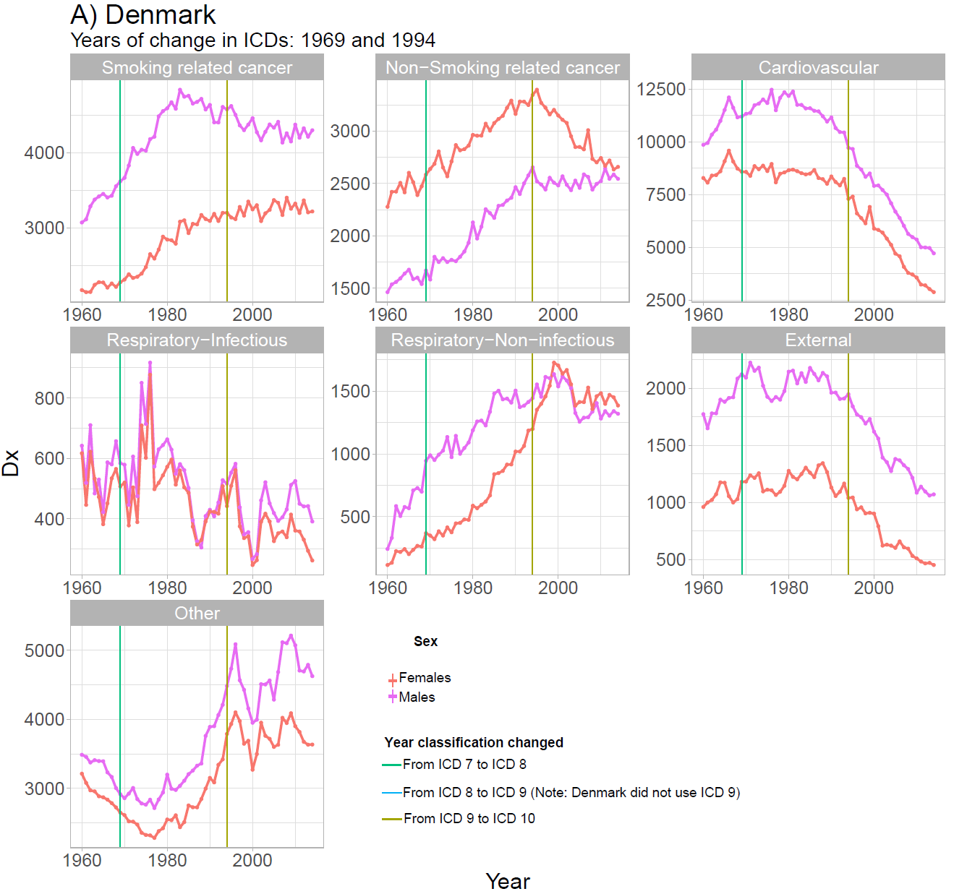

**4. Please, add extra information in the title of Figure 2 (similar to that of Supplementary Figure 1).**

We have made both figures consistent. The figure 2 now looks like:

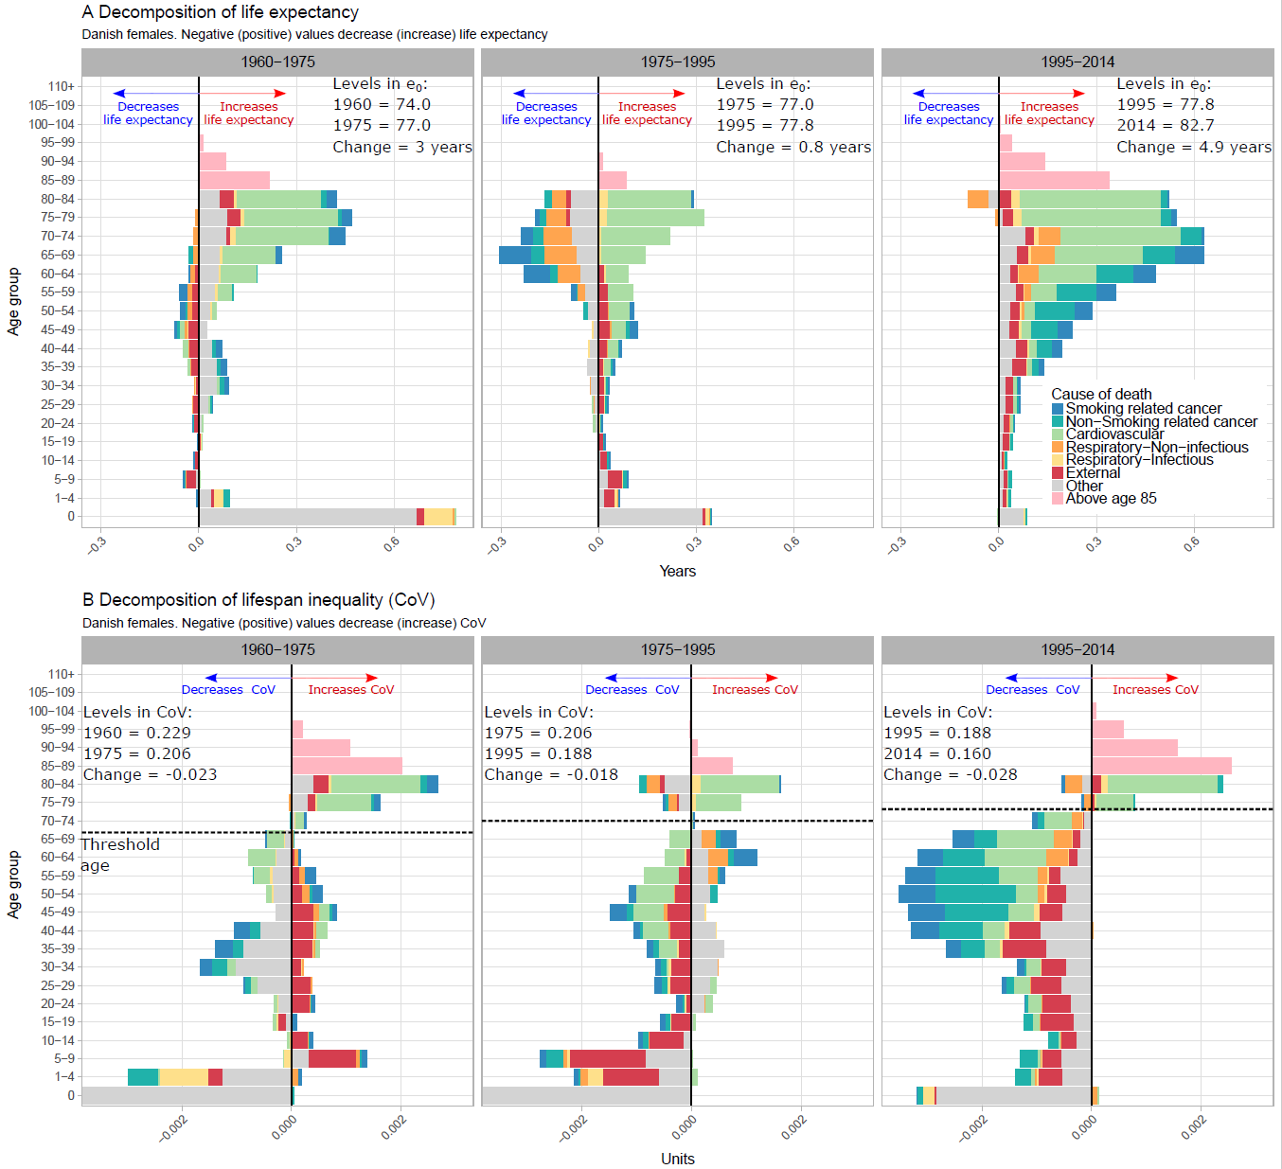

**5. In the Supplemental material "2) Brief description of the indicator" this is named CV. Change that to CoV as this is used in the text. Also chance "e0" to "ea" in the explanatory text to the formula (1).**

Thanks for this observation, we have made the corrections accordingly. It now reads:

$$CoV_{a}=\frac{\sqrt{\int_{a}^{ω}{{(x-e_{a})}^{2}f\left(x\right)\text{d}x}}}{\int_{a}^{ω}{l\left(x\right)\text{d}x}}=\frac{σ_{a}}{e_{a}}. (1)$$

Where $a,e_{a},σ_{a}$ and $ω$ denote the starting age at death of the density function, life expectancy at age $a$, the standard deviation at age $a$, and the open-aged interval (110+ in our case), respectively. We study the coefficient of variation from birth, i.e. $a=0$.

**Reviewer: 2**

**Sasson Isaac (Reviewer 2): This is an interesting descriptive paper looking at changes in life expectancy and lifespan inequality in Denmark from 1960 to 2014. The authors hypothesize that (1) Denmark will exhibit greater lifespan inequality relative to its neighboring countries; and (2) Life expectancy and lifespan inequality (variability) will stagnate between 1975 and 1995, primarily among women, due to higher smoking prevalence in the 1919-1939 birth cohorts.**

**Using HMD mortality data and WHO cause-of-death data, the authors find support for both hypotheses and point to possible health interventions with respect to infant mortality and cancers, which were responsible for the bulk of those patterns/trends (i.e., life expectancy and lifespan inequality improvements over time and relative to similar countries).**

**Overall, the paper is well written and the methods are appropriate. To their credit, the authors were mindful of possible limitations (e.g., ICD classification discontinuities, reliability of cause-of-death classification in old age) and addressed them in a satisfactory manner, either in the main analyses or in supplementary sensitivity analyses.**

**A few remaining suggestions:**

**1. The comparison with Sweden received substantial exposition (p. 3 second paragraph), as well as subsequent analyses (cause-of-death decomposition in Fig. 3), but not Norway. For example, Fig. 2 shows that Norway experienced similar stagnation in life expectancy and (more so) in lifespan variation from 1975-1995. In other words, Norway was closer to Sweden in levels but more similar to Denmark in trends. However, this similarity is not explored or explained, so I recommend that the authors either bolster the Denmark-Norway comparison or drop this third country altogether.**

We thank the reviewer for this observation. Given the points raised by the reviewer and our own assessment, we decided to leave out Norway. We do not lose any substance, and the comparison between Denmark and Sweden is the most instructive case in the region. In addition, omitting Norway helps focusing and highlighting this case.

Nevertheless, to address the reviewer’s point, the reason behind the Norwegian cohort based stagnation most probably has to do with a higher throughout life smoking prevalence for Norwegian females as illustrated in this figure (Jacobsen et al 2004):

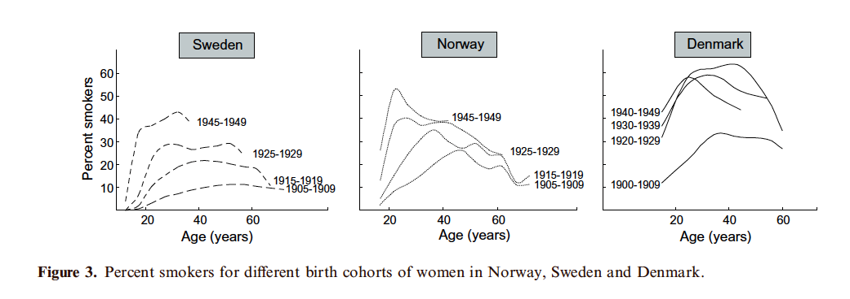

Thus, Norwegian women had higher smoking prevalence then Swedish women but much lower than Danish and may therefore have experienced a similar trend as Danish women but at a later point in time (e.g. 1980 instead of 1975) and to a much lesser extent.

Reference:

[Eur J Epidemiol.](https://www.ncbi.nlm.nih.gov/pubmed/15074566) 2004;19(2):117-21. Women's death in Scandinavia--what makes Denmark different? [Jacobsen R](https://www.ncbi.nlm.nih.gov/pubmed/?term=Jacobsen%20R%5BAuthor%5D&cauthor=true&cauthor_uid=15074566)1, [Von Euler M](https://www.ncbi.nlm.nih.gov/pubmed/?term=Von%20Euler%20M%5BAuthor%5D&cauthor=true&cauthor_uid=15074566), [Osler M](https://www.ncbi.nlm.nih.gov/pubmed/?term=Osler%20M%5BAuthor%5D&cauthor=true&cauthor_uid=15074566), [Lynge E](https://www.ncbi.nlm.nih.gov/pubmed/?term=Lynge%20E%5BAuthor%5D&cauthor=true&cauthor_uid=15074566), [Keiding N](https://www.ncbi.nlm.nih.gov/pubmed/?term=Keiding%20N%5BAuthor%5D&cauthor=true&cauthor_uid=15074566).

**2. The findings suggest that smoking-related cancers and non-infectious respiratory diseases had largely driven the stagnation in life expectancy from 1975-1995. Those same causes were responsible for positive contributions to lifespan inequality below age 70 (among women) and negative contributions in older ages—both of which attributed to rising smoking-related mortality across the board. In other words, the negative contributions from smoking were also undesirable, because they resulted from increasing mortality above the young-old threshold age, which the authors acknowledge in the discussion section (p. 11). I suggest introducing this concept earlier in the paper and plotting the threshold age in Fig 2, Panel B to make this point clearer.**

Thank you for the suggestion. We now introduce the concept of the threshold age since the Methods section:

“A particular attribute of lifespan inequality indicators is the threshold age that separates the ‘young-age component’, also called premature mortality, from the ‘old-age component’. Saving lives at any age result in increasing life expectancy. For lifespan inequality, improvements below the threshold age decreases inequality, while improvements above increase lifespan inequality.”

The corresponding part of Figure 2 now has the threshold age with a dotted line, it looks like:

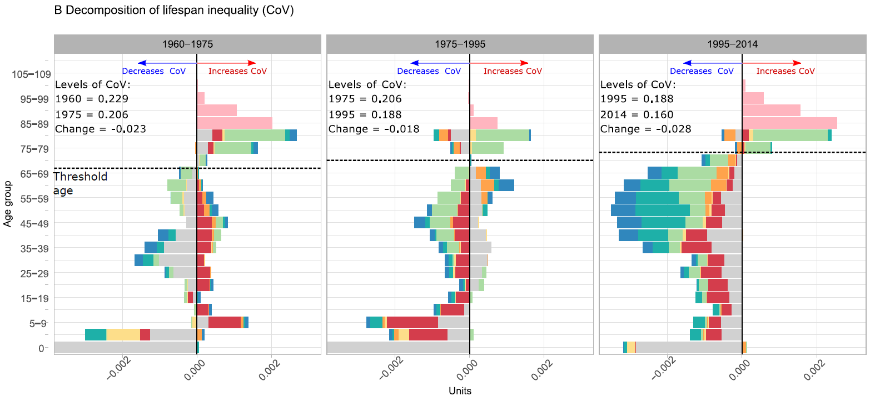

**3. The authors relied on CoV to measure lifespan inequality. However, because this measure is directly dependent on life expectancy, the interpretation of the findings (particularly comparison with other countries) is not always straightforward. For example, the CoV diverged between Denmark and Sweden in the 1980s, but we cannot tell whether the Swedish CoV declined because of absolute reductions in SD (numerator) or simply increases in life expectancy (denominator). Both effects would reduce the CoV, but each corresponds to a different mortality scenario (compression vs. translation). Therefore, I suggest applying alternative measures of lifespan inequality either in the main analyses or to be included in supporting materials.**

We thank the reviewer for this observation. It is true that lifespan variation indicators differ in their properties and interpretations (van Raalte & Caswell 2013). However, the correlation between them is high, almost always above .9 in terms of Pearson correlation coefficient (Colchero et al 2016), which suggests that the main results would not differ if we had chosen a different indicator. We chose the coefficient of variation for three main reasons: 1) It is a standard statistical indicator, 2) it is easy to interpret as the relative deviation from the mean of a distribution, 3) and it is dimensionless. Other indicators of relative inequality exist that have been successfully used and decomposed as we do in our paper, for example the Gini coefficient (Scholnikov et al 2013), or Keyftiz’ entropy (Vaupel & Canudas-Romo).

On the other hand, there exist indicators of absolute inequality not divided by the mean, that have the advantage of being interpreted in years rather than units. For example, life disparity (Vaupel et al 2011), the standard deviation and the variance of the age at death distribution (Edwards & Tuljapurkar 2005). In order to test the robustness of our results, we replicated the main figures of our paper using the standard deviation of the age at death distribution, which as you noted, is the numerator of the coefficient of variation.

Figure 1 below shows trends in the standard deviation for Sweden and Denmark. Although the levels differ, the results in trends do not differ as the trends shown in the coefficient of variation. Figure 2 and 3 show the age and cause-decomposition over time of the standard deviation for females and males, respectively. As with the coefficient of variation, infant mortality was the main driver of trends in lifespan variation before 1995. In the period of stagnation, the differences are very small compared to the coefficient of variation. Moreover, at ages above 70 the effect of smoking-related mortality is slightly higher for females, but undesirable, as you pointed out in another suggestion. Finally, figure 4 shows the difference between Sweden and Denmark in the standard deviation. Results are very similar indicating the clear policy target that we propose in the manuscript: Denmark could reduce inequality of lifespans and increase life expectancy by focusing on reducing infant and cancer mortality.

To alleviate any concern to the reader we have included these results in the supplementary material and added a couple of sentences in the methods section regarding the properties of lifespan variation indicators. In addition, we acknowledge doing this sensitivity analysis in the discussion section and refer the reader to the supplementary material.

Figure 1. Trends in the standard deviation for Sweden (green) and Denmark (red).

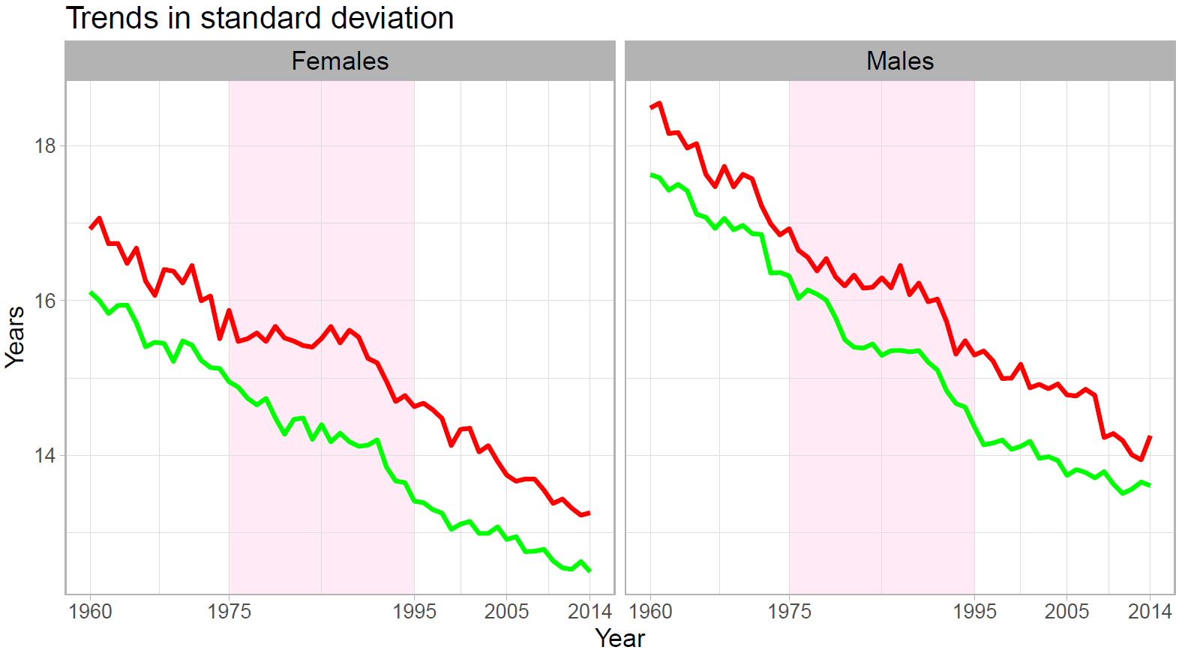

Figure 2. Age and cause-decomposition of the changes in the standard deviation for Danish females. Note: the age zero is truncated for visualization purposes.

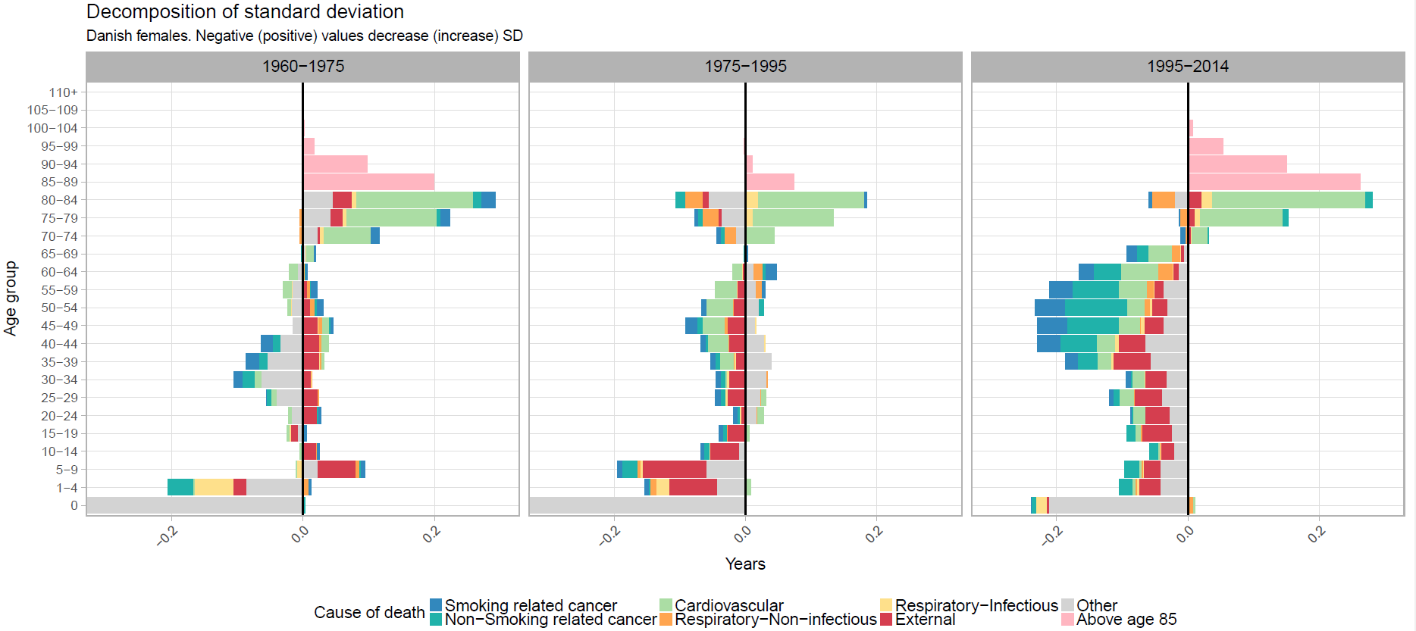

Figure 3. Age and cause-decomposition of the changes in the standard deviation for Danish males. Note: the age zero is truncated for visualization purposes.

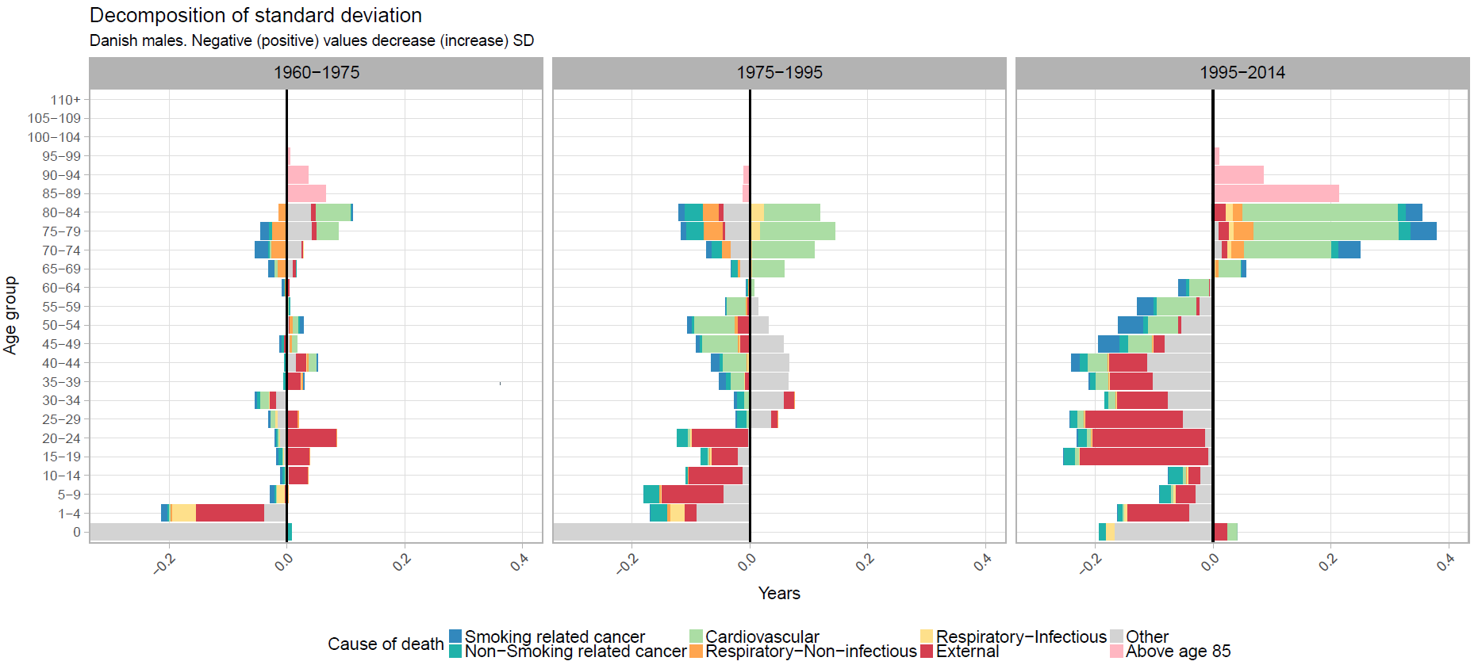

Figure 4. Age and cause-decomposition of the difference in the standard deviation between Denmark and Sweden 2014.

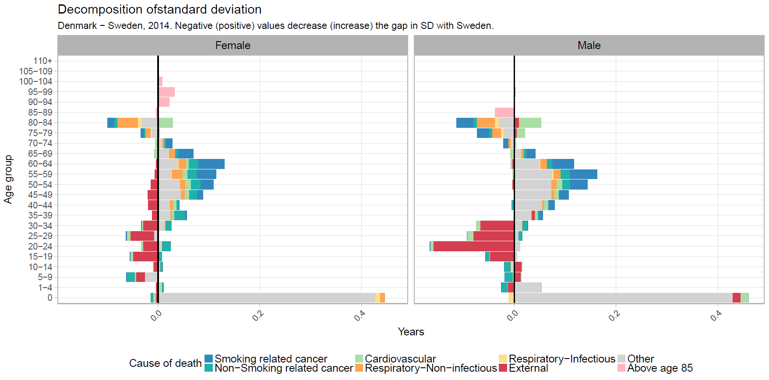

**4. It appears that non-smoking cancers also contributed to reductions in life expectancy and increases in lifespan inequality during the 1975-1995 period. Can the authors explore this further? Is this because their definition of smoking-related cancers was conservative, as explained in the Supplementary Materials, so some of the effect of smoking is captured in the remaining cancers? Or was there an overall cancer crisis (e.g., diagnosis, treatment) going on in Denmark? This is relevant to the interventions discussed at the end of the paper.**

This is a challenging question with various potential explanations, some of which were already given by the reviewer. The conservative definition of smoking-related cancers is one of them. Competing risks is another: people who previously died of other causes now die of cancer, and these increased cancer rates would show up as holding back life expectancy. In this respect, we note that non-smoking related cancer was on the rise also in Sweden, so it is likely not a phenomenon specific to Denmark. Specifically for Danish females, other risk-taking behavior may have led to increased cancer rates in general. It is well-known (in Denmark) that Denmark was a laggard in terms of cancer mortality, leading to various cancer plans from 1990 onwards.

We added the next paragraph in the discussion:

“In the 1975-1995 period, non-smoking cancers also contributed (albeit to a small extent) to reductions in life expectancy and increases in lifespan inequality. The conservative definition of smoking-related cancers in this paper is one explanation for this phenomenon. Competing risks is another: people who previously died of other causes could die of cancer, and these increased cancer rates would show up as holding back life expectancy. In this respect, we note that non-smoking related cancer was on the rise also in Sweden, so it is likely not a phenomenon specific to Denmark. Specifically for Danish females, other risk-taking behavior may have led to increased cancer rates in general.(13,14)”

**5. Phrasing: p. 11, first paragraph: "Therefore, the causes that extend lifespan and the causes that reduce inequality are not necessarily the same." I recommend changing "lifespan" to "average lifespan" or "life expectancy" so there is no confusion with "maximal lifespan."**

Thank you, we agree with this suggestion and have changed ‘Lifespan’ to average lifespan or life expectancy throughout the manuscript.